Monthly School newsletter

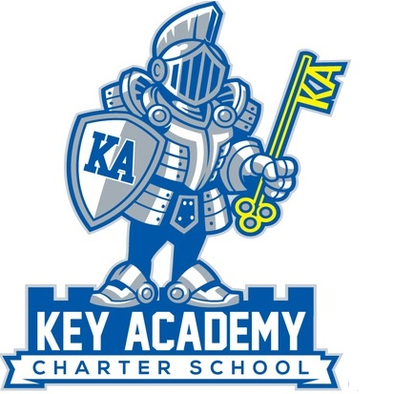

Newsletter November

Volume 1, Issue 3

u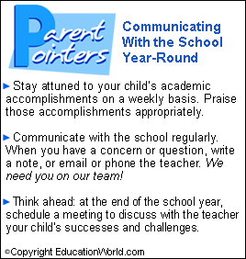

KEY Academy tee-shirts and other items are available for purchase at the following website:

We are asking parents to grant us a favor by not parking in the back while dropping off students. We try to keep those parking spaces reserved for teachers. Thank you so much!

# Parking



We will finally start our after school program this month. The after school program will begin Monday, November 18th. Homework help will be offered on Monday and Wednesday from 3:30-4:15 pm in the Homework Club. Students must sign up for this program. A sign-up form will be sent home shortly. Please fill it out and send it back to the office if you would like to participate in the Homework Club.

Some students will be required to stay for the Intervention/ELD program on Monday and Wednesday afternoons. Your classroom teacher will inform you if your child is required to participate in this program. Again, this is a requirement and we appreciate your support. We want to ensure that we are helping everyone succeed.

On Tuesday and Thursdays we will be working with outside vendors to provide different enrichment programs for our students. These programs will have a fee associated to them and are subject to change depending on student participation and interest. A sign-up sheet will be sent home for these programs soon.

# Buy your KEY Academy Spirit Wear

The first couple of weeks of school have flown by and it’s that time of the year for report cards. We will be holding our parent conferences on Monday, November 4th and Tuesday, November 5th from 1:30 pm to 3:30 pm. If you cannot make these times, please call the teacher to arrange another time. We want to meet with everyone!

# Parent Conferences

# After School Program

# Chuck E Cheese

On Friday, November 8th, we are holding our first annual Walk-a-thon/Jog-a-thon. We are asking students to find different sponsors to sponsor them in this event. Sponsors have a choice to set a monetary amount per lap a student intends to complete or can name a maximum amount that they are willing to contribute to the student. Checks should be made out to KEY Academy. All money needs to be collected prior to the event. Students who collect twenty-five dollars in contributions will receive a free KEY Academy tee-shirt. All proceeds will help fund the purchase of electronics for our classrooms. Our goal is to reach $5,000.00.

The event will start at 9:30 am and will end at 12:30 pm. Everyone is welcomed to come. During the Walk-a-thon/Jog-a-thon there will be different stations for students to stop by at.

We are still looking for volunteers to help at the different stations. We are also looking for donations to buy face paint, bean bags, and snacks.

# Walk-a-thon/Jog-a-thon

It was fun seeing everyone on October 10th at Chuck E. Cheese and getting to play games with each other. Amidst all the fun we were able to also fundraise $260.00 for the school.

# Recess Soccer

We had our first two soccer games with Faith Ringgold this past week. Our soccer teams have been practicing very hard over the last few weeks and I am proud of how well you all played! We will be having our next game on November 13th. Those students who didn’t start in Thursday’s game will be starting in the next games. GO KNIGHTS!

**Parent Volunteers**

Thank you so much to all the volunteers who have been helping during lunch time and donating supplies to the School. You support and dedication make all the difference! Our next parent meeting will be in December.

**Parent Conferences**

Monday, Nov. 4th and Tuesday, Nov. 5th (1:30-4:30)

**Walk-a-thon/Jog-a-thon**

Friday, November 8th (8:30 am-12:30 pm)

**Veteran’s Day**

Monday, November 11th (NO SCHOOL)

**Soccer Game with Faith Ringgold**

Wednesday, November 13th

**After School Program**

Monday, November 18th

**Make-up Picture Day**

Wednesday, November 20th

**Thanksgiving Break**

Monday, Nov. 25th-Friday, Nov. 29th

Chocolate and Stickers are still on sale in the office! Bring back the money to the office after you have sold the items. We are also collecting cans and plastic to recycle.

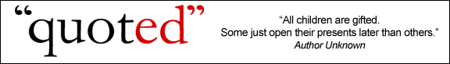

**Bring in your Box Tops!**

Help us earn money for our school by clipping 10¢ Box Tops from hundreds of products and bringing them back to the School.

You can find Box tops on:

* Office supplies
* Paper products
* Storage containers
* Baking goods

The class that brings the most in by the end of December will win a pizza party.



# Parent’s Corner

## Upcoming Events

[](http://www.google.com/imgres?q=remind&um=1&hl=en&rlz=1R2ADRA_enUS422&biw=1280&bih=733&tbm=isch&tbnid=SfgePQqkGphG-M:&imgrefurl=http://dzspeakingenglish.blogspot.com/2010/05/tip-remember-vs-remind.html&docid=SNnwgYoeSmt5LM&w=306&h=303&ei=qYthTrOiBMHmiALT8t29Dg&zoom=1)

# Character Counts

We had our Respect assembly on October 16th. It was wonderful to see so many names in the jar for the drawing and students on the stage getting their awards for being respectful! Keep up the good work!

This month we will be focusing on the character trait, responsibility.

When you are responsible, you do what is asked of you and take seriously whether at home or at school. You always follow through with what you say you will do because you are trustworthy-people know they can count on you! You always complete tasks to the best of your ability and if mistakes are made you accept advice and help from others. You are willing to learn for your mistakes, that is truly taking responsibility for your actions.



*Sebastian Valero *Alex Aguilar

*Adam Albutmeh *Ana Gomez

*Anahi Gomez *Odalys Arechia

*Carlos Valencia *Leen Armoush

*Alejandra Jimenez *Tuliana Seiuli-Phelps

**Winners from the Drawing (Respect tickets):**

*Salvador Valero *Eduardo Martinez-Castaneda

**Winners from the Drawing (Perfect Attendance):**

*Imaan Achikzai *Ahizari Arzate Castellon

# Character Kid Awards



**KEY Academy School Newsletter Page 2**